Motivation letter submission guidelines
For master’s students

Complete the following information, using the template hereafter:
- First name and surname
- Your nationality
- Affiliation of your university
- Your country of study
- What diploma are you preparing this year?
- Email of contact

Motivation letter must be written in English.

Motivate your participation to the Photonics TALENT International Summer School :
- Tell us why you'd like to take part in the Summer University?
- Tell us about your greatest achievement (academic or professional)
- Explain what is your career plan?
- Explain what you expect from this event?
- Write about 20 lines

The submission of motivation letters for master’s students will open on January 13th, 2025.

Submission process calendar

- Submit your motivation letter before February 9th, 2025.

- Participation to the Photonics TALENT Summer School is subject to review by the scientific committee from February 10th until February 23 th, 2025.

A limited number of letters will be selected, and these students shall receive a scholarship to take part in the Summer School. If your letter is selected, you will be notified with the acceptance email between February 24th and March 2nd.

After receiving acceptance notification, you will need to confirm acceptance by registering and paying on the SciencesConf platform between March 3rd and 23th. For students with grants, you must send us proof of your tickets to be reimbursed.
Registration will close on March 23th.

- Organize your visit to the summer school. We look forward to seeing you in Bordeaux on July 15th.

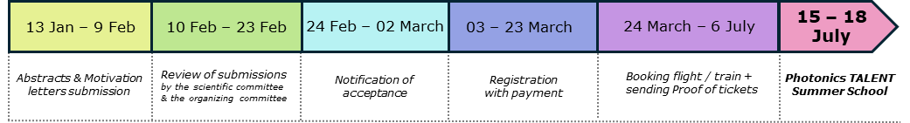

Motivation Letter

Name:
Affiliation of your university:
What diploma are you preparing this year:
Email of contact:

First name and surname:
Your nationality:
Affiliation of your university:
Your country of study:
What diploma are you preparing this year:
Email of contact :

Motivate your participation to the Photonics TALENT International Summer School writting about 20 lines.

