**Abstract submission guidelines**

*For PhD students*

Complete the following information, using the template hereafter:

* Title of the abstract
* Author’s names
* Email of contact
* Affiliation of university
* Country of study

Abstracts must be written in English.

The abstract should state the most important specific objectives, the major results (or expected results if none are applicable at this stage), and the most significant conclusions of the work.

Prepare your abstract relating to the topics covered during the summer school:

* **High-Performance Lasers for Industrial Applications**
* **Laser source development for Scientific Applications**
* **Lasers for Advancing Medical Applications**

Please provide complete and accurate bibliographic information for all cited sources in the reference list. Include illustrations and captions.

The submission of abstracts for PhD students will open **on January 13th, 2025.**

**Submission process calendar**

* Submit your one-page abstract **before** **February 9th, 2025.**
* Participation to the **Photonics TALENT Summer School** is subject to **review by the scientific committee from February 10th until February 23 th, 2025.**

A **selection of posters** will be considered for the poster session (with poster award). If your abstract is selected, you will receive a notification by email to send in your poster. You will receive an email informing you of the committee’s decision **between February 24th and March 2nd.**

After receiving acceptance notification, you will need to **confirm acceptance by registering and paying** on the SciencesConf platform **between** **March 3rd and 23th**. **Registration will close on March 23th.**

* **Organize your visit to the summer school**. We look forward to seeing you in Bordeaux **on July 15th.**

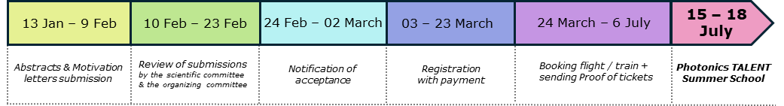

**Title of the Abstract**

Author’s name:

Author’s email:

Affiliation:

Abstract

*One page abstract with figures.*